T-Shirt - front

Stop
Alabama Rot

The A

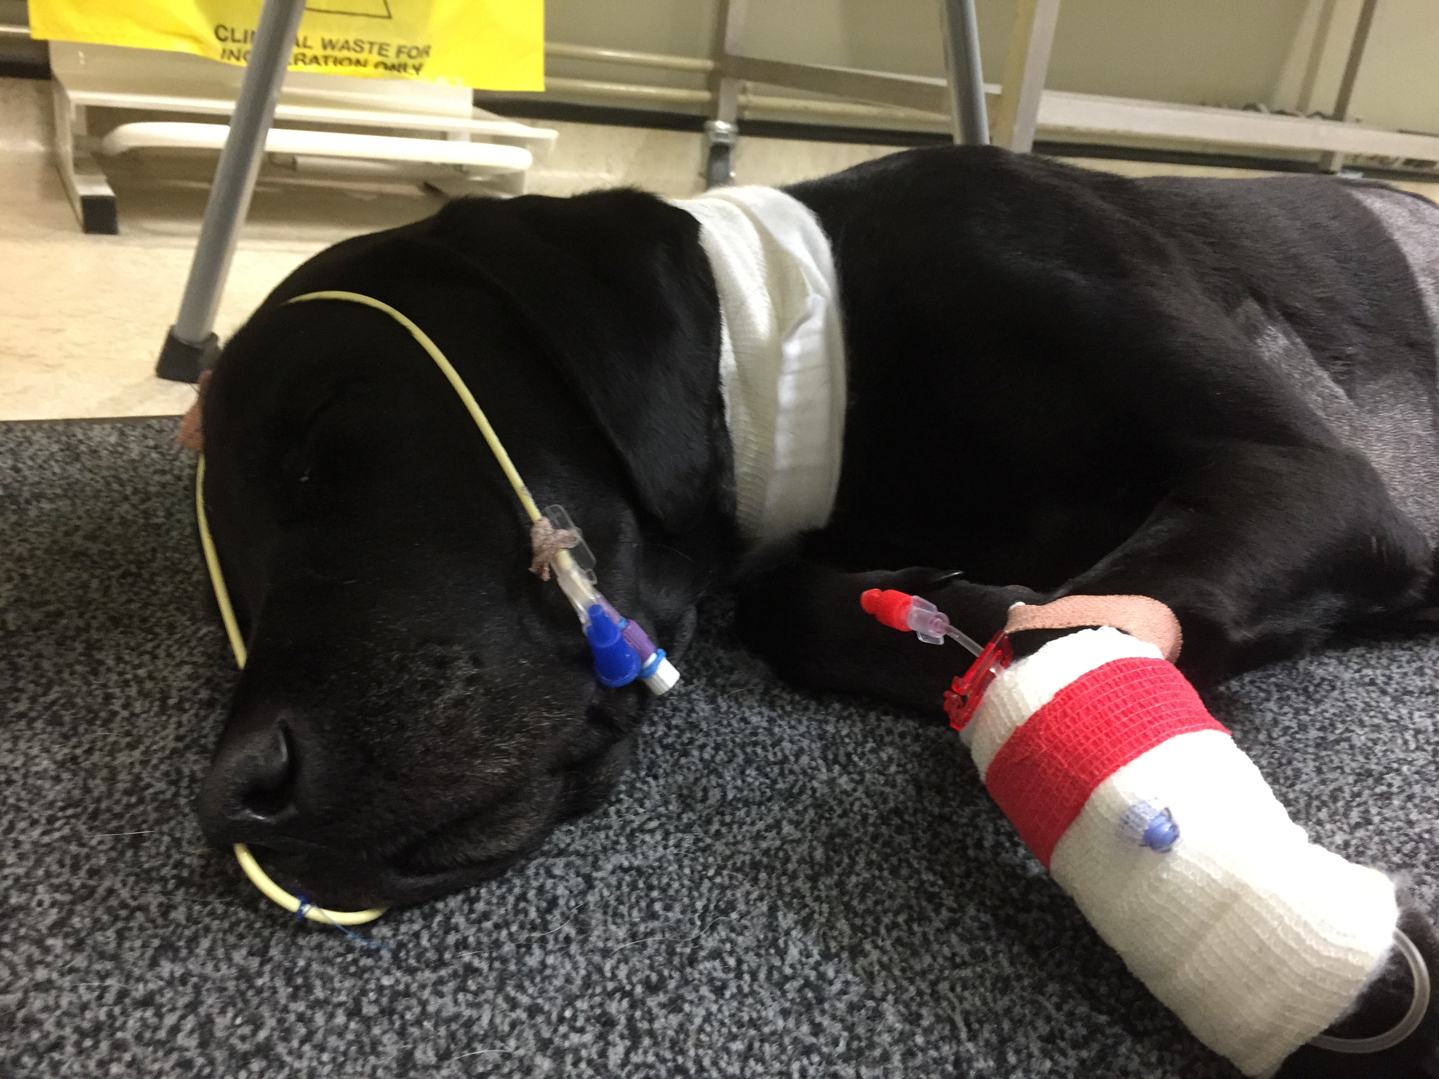

Your event message

T-Shirt - back
Donate by Text*
To donate £1, text ARRF to 70201
To donate £3, text ARRF to 70331
To donate £5, text ARRF to 70970
To donate £10, text ARRF to 70191
or for a larger donation visit www.arrf.co.uk

Alabama Rot Research Fund

Registered charity number 1166029​

*Text donations may incur a standard text message fee depending on your agreement with your mobile service

